









**Implementation Phase: Final Output(no error)**

**Step 1: Add Devices**

1. Open **Cisco Packet Tracer**.

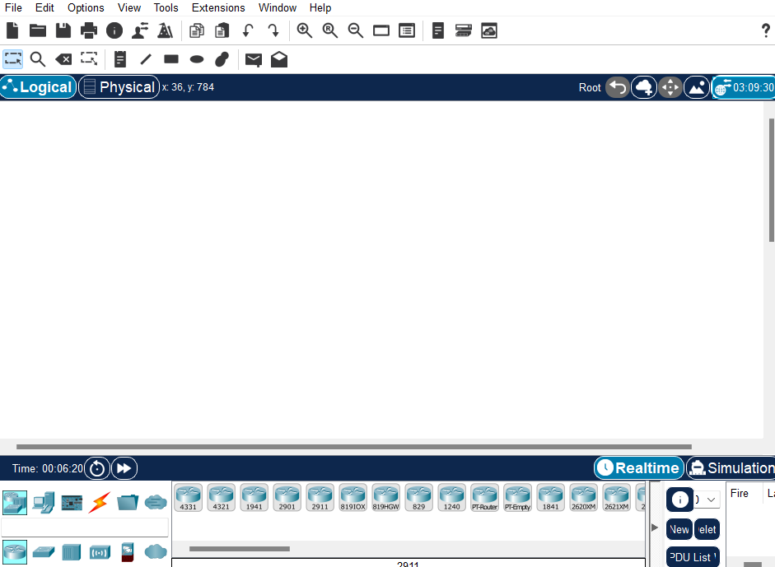

Add **1 switch** (e.g., **2960**). And drop **3-4 PCs** from the **End Devices** category.

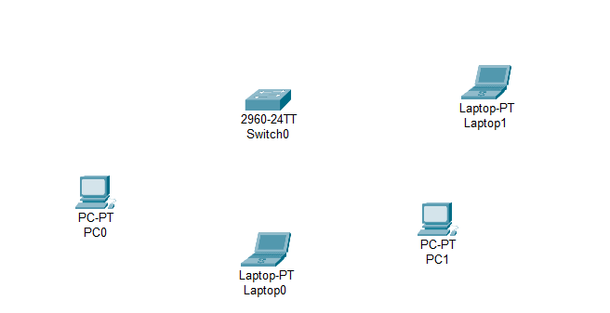



**Implementation Phase: Final Output(no error)**

**Step 2: Connect PCs to the Switch**

1. Click on the **Connections** icon
2. Select **Straight-Through Cable**.
3. Click on **PC0**, choose **FastEthernet0**.
4. Click on the **switch**, choose an available **FastEthernet port** (e.g., **FastEthernet0/1**).

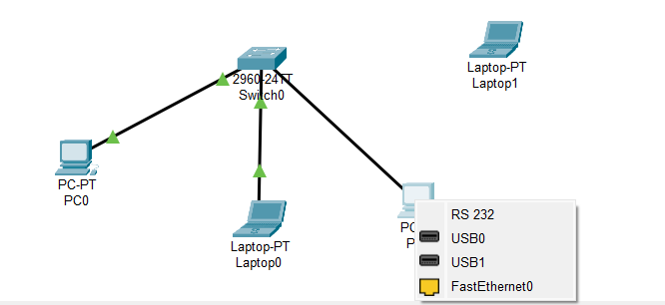

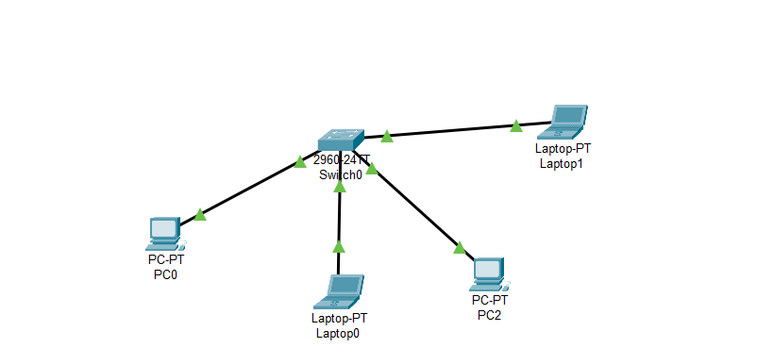



**Implementation Phase: Final Output(no error)**

**Step 3: Assign IP Addresses**

1. Click on **PC0**, go to the **Desktop** tab.
2. Open **IP Configuration** and assign:
   * **IP Address:** 192.168.1.2

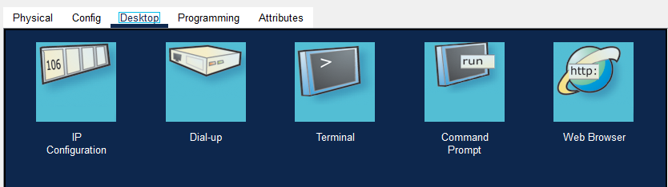

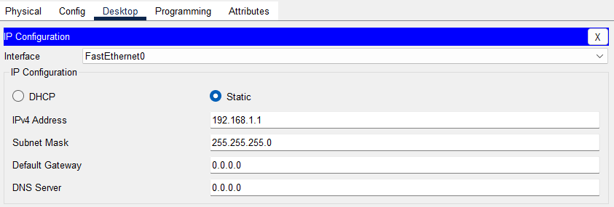

**Ping the Broadcast Address**

1. Open **PC0** → Go to **Command Prompt**.
2. Type: ping 192.168.1.255

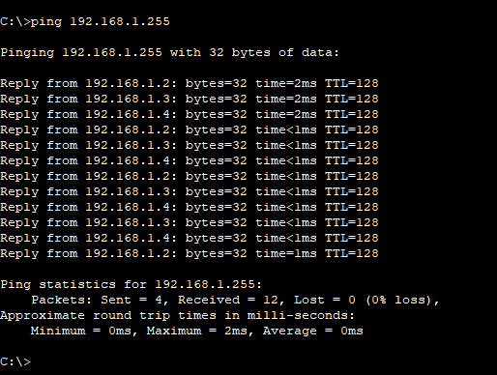



s







        
        
        
        
        
        
        
        
        



